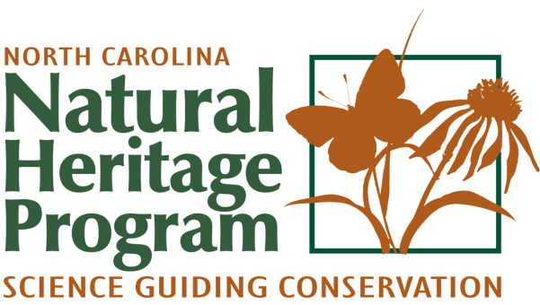

Please submit this form by email: natural.heritage@ncdcr.gov
Or mail:
N.C. Natural Heritage Program
Information Request
1651 Mail Service Center
Raleigh NC 27699-1651

Information Request Date submitted ___________ Date received _____________
The North Carolina Natural Heritage Program provides information on the distribution of rare animals, rare plants, natural communities, Natural Heritage Natural Areas, Dedicated State Nature Preserves, and Registered Heritage Areas. To request information, please complete this form and submit to NCNHP. Responses to information requests will typically be provided in two weeks; however, complex requests or requests received during periods of heavy workload may require additional time.

Contact Information
Name
Company
Street Address
City ST Zip Code
Phone
Fax
E-Mail Address

Project Information
Project Number
Project Location | Latitude _____________ Longitude _____________ (in decimal degrees)
 | County ___________________ Topographic Quad _______________________
Project Type: Sensitive Environment __ Transportation __ Forestry __ Energy __ Other __

Project Description: Please provide all of these * items with your request.
*1. This completed information request form.
*2. A cover letter describing the proposed activity, including existing vegetation cover, structures at the site, and the type of data requested. Additional pages may be provided by email attachment or through the mail.
*3. A copy of appropriate USGS topographic map with the project area clearly outlined.

Additional information that would be useful:
a. GIS shape files of the project area.
b. A county map with major highways, rivers, creeks, and towns labeled is acceptable if accompanied by a project site map.
c. Project boundary overlaid on a recent aerial photo
d. Parcel identification number(s) for the project area

